PROJECT PROPOSAL
Kamata School
Website & Management System
A modern public website, online admissions, a staff content portal and automatic timetabling, in one secure platform.
PREPARED FOR  Kamata School  info@kamataschool.com | PREPARED BY  David Kamadi  Software developer
Date: 20 October 2026 Confidential: prepared for Kamata School only

1 Executive summary
We propose to provide Kamata School with a modern website, online admissions and a staff content portal. Most of the platform is already built and tested, so it can go live in weeks rather than months.
The platform has four parts that share one secure system:
- Public website: a fast, mobile-friendly site, readable in several languages, for prospective students, parents, staff, alumni and partners. School staff can change every word and photo.
- Online admissions: applicants create an account, complete a 7-step form that saves as they go, upload documents, pay the application fee and track their status. They also receive and accept their offer online.
- Admin portal: staff manage pages, photos, menus, applications, users and permissions from a web browser, with no developer needed.
- Timetables: staff build each term's class timetable automatically, with no room, lecturer or class ever booked twice at the same time, and publish it on the website.
The school gains a professional public image, fewer paper applications, faster admissions decisions and full control of its own content. Security and data protection follow the Kenya Data Protection Act 2019.

2 The challenge
A school website is now the first place most applicants and parents meet the institution. Many Kenyan institutions face the same problems online:
- Out-of-date content. Changing a page needs a developer, so news, fees and deadlines go stale.
- Paper or PDF admissions. Applicants travel or print forms. Staff re-type data, chase missing documents and lose track of files.
- No clear fee path. Applicants cannot see how to pay the application fee or confirm that it was received.
- Slow pages on mobile data. Heavy sites fail the many visitors who browse on a phone.
- Weak data protection. Applicant documents and personal data are often stored without access control, which risks breaching the Data Protection Act 2019.
This proposal addresses each of these directly.

3 Proposed solution and objectives
We will deliver one connected platform rather than a set of separate pages. Its design draws on well-regarded institution websites, chiefly Ashesi University (Ghana), whose audience and bandwidth conditions closely match those in Kenya.
The platform has five objectives:
- Present the school's identity, programmes, facilities and community with real campus photography.
- Make the main visitor tasks obvious: explore programmes, understand admissions, apply and contact the school.
- Move the full admissions process online, from first application to accepted offer.
- Let staff edit every word, photo, menu and page without a developer.
- Protect personal data, and keep the site fast on a phone using mobile data.

4 What the platform does
Everything below is built and working today on our demonstration system, except items marked planned integration, which are added once the school chooses its providers.

Public website
Feature | What it does
Main pages | Home, About Us, Academics, Admissions, Student Life and Contact Us, all drawn from the content system
Page builder | Pages are built from 18 ready-made blocks: hero banner with up to 3 buttons, text, images, image with text, photo gallery, cards, key statistics, timeline, call to action, FAQs, tabs, testimonials, YouTube or Vimeo video, map, downloads, contact form and child-page lists
Language switcher | Visitors pick a language (for example Kiswahili, French or Arabic) from the header, and the whole site switches: pages, menus, buttons and contact details. Staff add languages and write each translation in the admin portal; untranslated pages show in English with a short notice
Legal pages | Terms of Service, Privacy Policy and Data Processing Agreement, with recorded consent
Search engines | Clean web addresses, page descriptions and server rendering so pages appear in Google results
Mobile-first | Fast on a phone over slow mobile data; photos are resized automatically

Online admissions
Feature | What it does
Applicant account | Applicants register, agree to the terms and sign in securely
7-step application | Personal details, academic history, programme choice and more; progress saves as they go
Documents | Applicants upload certificates and ID; files are private to the applicant and staff
Application fee | Applicants see the fee and payment instructions and enter their M-Pesa code; staff confirm it
Status page | Applicants see each stage: submitted, under review, information requested, offered, rejected
Offer letter | Applicants download a PDF offer letter and accept or decline online before a deadline
M-Pesa STK Push | Planned integration: payment prompt sent straight to the applicant's phone
Email and SMS alerts | Planned integration: updates sent to applicants as their status changes

Admin portal for staff
Feature | What it does
Secure staff sign-in | A dedicated staff sign-in page with two-step login; the browser does not suggest applicants' saved emails on shared computers
Page editor | Create and edit pages with a live preview; save drafts, schedule publishing, send for approval and restore old versions
Media library | Upload photos and files once and reuse them; images are resized automatically
Menus and settings | Change the menus, header, footer, contact details and every piece of interface text
Languages | Add languages and translate pages, menus and site details
Redirects | Keep old web addresses working after a page moves
Applications | Review applications, request more information, offer or reject, confirm fees and export to Excel (CSV)
Ready-made decision messages | Offer, not-successful and request-for-information messages are pre-written and filled in with each applicant's name, programme, intake and deadlines; staff check and send
Admissions setup | Manage programmes, intakes and the documents each applicant must supply
Users and roles | Give each staff member only the access they need, limited to one section if required
Audit log | A record of every sign-in and every change made in the admin portal
The school's existing student portal stays in use; the website links to it.

Timetable management
The system builds a clash-free weekly timetable for every term, following the method used by timetabling software worldwide.
Feature | What it does
Setup | Rooms (seats and type, e.g. computer lab or workshop), lecturers (times they are unavailable, daily limit), classes and units are entered once and reused every term
Lessons | For each term, list what each class is taught: unit, class or combined classes, lecturer, sessions per week, and single or double periods
Automatic timetable | One click places every lesson, spreading each unit across the week and choosing the best-sized room; anything that cannot fit is listed with the reason
No clashes, ever | A room, lecturer or class is never booked twice at the same time; sessions never cross a break; rooms are big enough and of the right type; lecturers are only booked when available
Adjust by hand | Click a session to see which slots are free and why others are blocked; lock sessions so they stay in place
Published timetable | Students and lecturers view the timetable on the website by class, lecturer or room, and can print or share it
In testing, a demonstration school of 5 classes, 10 lecturers and 46 weekly sessions was fully timetabled in under one second, with no clashes.

5 Technology, security and data protection
The platform uses widely supported, modern tools: Angular for the website, Node.js (NestJS) for the server and a MySQL database. The browser never talks to the database directly.

Quality results
Tested on 1 October 2026 with Google Lighthouse on a throttled phone over slow 4G.
Check | Result
Accessibility | 100 / 100 on every page checked
Best practices | 100 / 100 on every page checked
Search engine optimisation | 100 / 100 on public pages
Performance | 85 to 90 / 100
Server software vulnerabilities | 0 found

How the platform protects the school
- Strong sign-in. Passwords are stored with Argon2id, a modern standard, and common passwords are refused. Staff must also use two-step login with a phone app.
- Lockout and limits. An account locks for 15 minutes after 5 failed attempts. Staff are signed out after 15 idle minutes.
- Least access. Every admin action checks a named permission. Applicants can only ever see their own application.
- Private documents. Applicant uploads are stored outside the public site and served only to the applicant and authorised staff.
- Safe uploads. Files are checked by their real type, and images are re-processed before they are stored.
- Audit trail. Every sign-in and every change in the admin portal is recorded and searchable.
- Safe go-live. The live system refuses to start if any security setting is unsafe, such as a missing secret or a non-HTTPS address.
- Backups. One command backs up the database and all files. A second restores the latest backup into a test database and checks every table, row and file.

Data protection
The platform supports compliance with the Kenya Data Protection Act 2019. Applicants must accept the Terms and Privacy Policy, and the system records when they accepted and which version. Before launch, the school registers with the Office of the Data Protection Commissioner (ODPC), names a Data Protection Officer and has an advocate review the legal pages.

6 Implementation plan
Because the platform is already built, the remaining work is mainly the school's own content, set-up and launch. It runs in four phases, each ending with the school's sign-off.
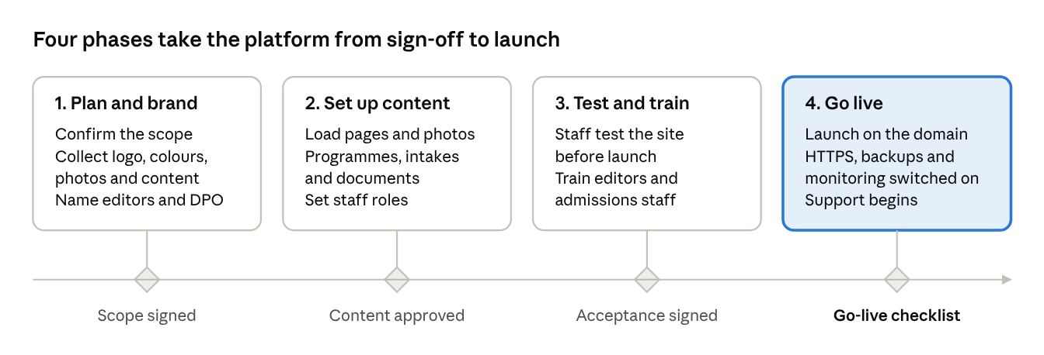
Each phase starts only after the school signs off the gate before it. Phase lengths will be set in the agreed project schedule.

Training
- Hands-on sessions for content editors: editing pages, adding photos, publishing news and managing menus.
- Sessions for admissions staff: reviewing applications, confirming fees, issuing offers and exporting lists.
- A short written guide for each role, and one super administrator trained to manage users and permissions.

Support after launch
- Fixes for defects found after go-live.
- Monthly maintenance: security updates, backup checks and software updates.
- Extra support during admission and fee-payment peaks.
- A yearly accessibility check and security test.
Response times will be agreed in a support agreement.

7 Benefits to the school
For | Benefit
Prospective students | Apply from a phone, any time, without travelling or printing forms
Parents and sponsors | Clear information on programmes, fees, admissions and contacts, in their own language
Students and lecturers | An up-to-date, clash-free timetable on the website, by class, lecturer or room
Admissions office | All applications, documents and fee confirmations in one place, with ready-made decision messages and one-click export
Academic office | A term's timetable in minutes instead of days, with no double bookings
Communications staff | Update news, photos and pages the same day, without a developer
Management | A professional public image, an audit trail, and data handled in line with the law

8 Next steps
- Review this proposal and agree the scope and investment.
- Sign the agreement.
- Supply the logo, brand colours, photos and page content.
- Name the content editors, approvers and Data Protection Officer.
We would welcome the opportunity to demonstrate the platform to the school's management, at the school or online, at a time that suits you.

9 Acceptance
By signing below, both parties agree to proceed on the basis of this proposal.
 | For Kamata School | For the developer
Name |  | David Kamadi
Title |  | System Developer
Signature |  | 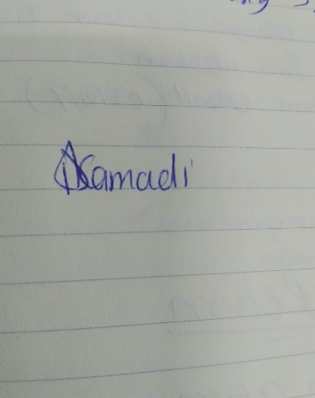
Date |  | 20 October 2026

